Certificaciones
https://www.credly.com/badges/80be19cb-8d54-42b5-9cac-94135f2f9f7c/public_url
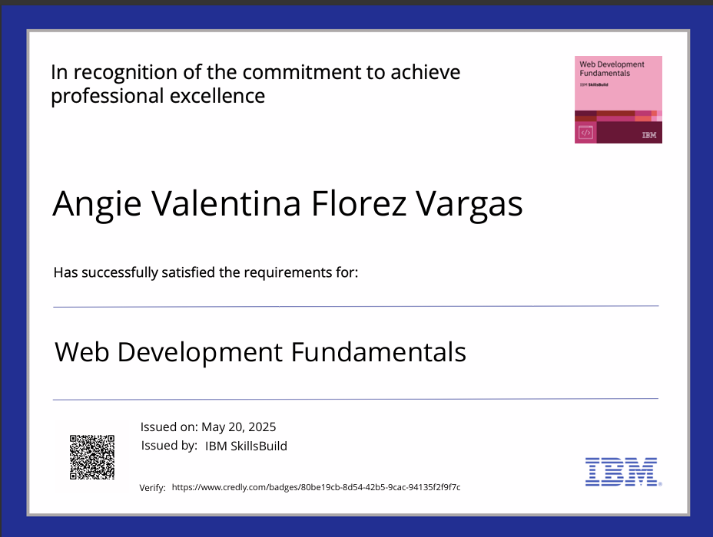

https://www.credly.com/badges/eab592b4-5a17-491b-9786-85fce41a8ee6/public_url
